**Introduction**

This year I was developing a device that will detect metallic materials and display the shape of the detected object. The device name was chosen eK9. The name was chosen in one of the lectures on project management. Most of the class was suggesting this name will be best and I liked it.

**What is eK9?**

eK9 is a simple smart metal detector. This device can detect an object at a distance of 10-15 cm. The device reacts differently to different materials. If steel is detected the device will show reading different then on the detection of aluminum or other non-magnetic metals.

**Design**

In the beginning, I was trying to build a powerful metal detector. But it consumed to much time and I didn’t finish the circuit on time. All first semester was consumed on building hardware. Original idea was to build a dual power supply with the virtual ground and positive, and negative + volt outputs. This power supply was supplying power for op-amps which were crating sinusoidal waveform. I connected coil to output and noise was appearing on the signal. I was hoping that I will be able to use this setup. Next thing I was thinking to add op-amp in differential amplifier configuration and feed signal from both coils. On output, I was hoping to get a difference in signal. But this was not happening. So, I decided to go a different way. At the beginning of the project, I wanted to use 555 timers as my project but this setup cant increase power to the coil. The device will be not that powerful. I used a simple circuit where 555 timer uses a coil and when any metallic material amperes near coil output frequency was changing. I modified the circuit that I was able to get square waves from 0 to 3.3 volts.

**eK9 sensor and how it works**

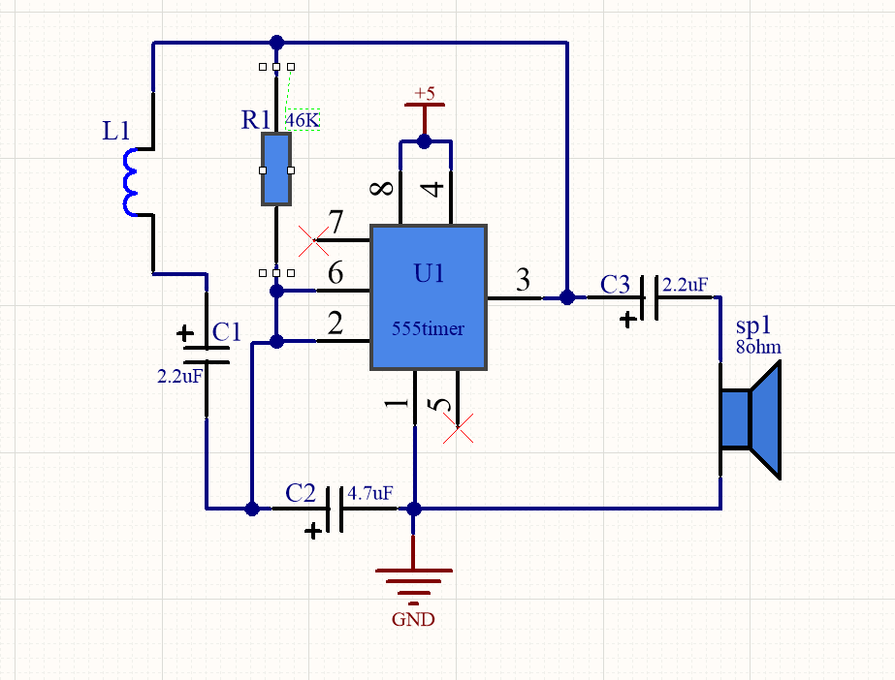

*555 timer circuit using the coil to vary the output.*

Before I have seen the circuit, very simple which using 555 timers, coil, and speaker to notify the user. Youtube is full of that circuit. So I decided to use that circuit and add some modifications. I removed the speaker and instead added a resistor. Measured output with an oscilloscope. 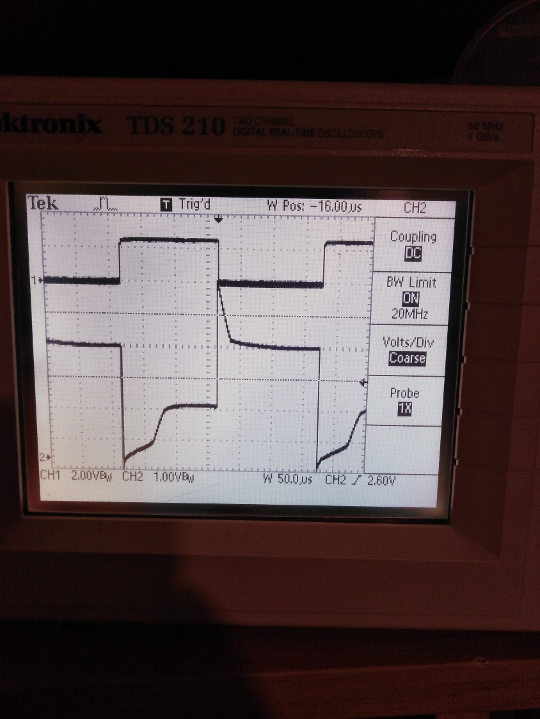

The frequency was steady 3.1kHZ. I tested different materials like steel aluminum copper, gold. I noticed that id I use material which are attracted by magnet frequency vas decreasing and if aluminum coper or good frequency was increasing. In the future, I will use this to approximate materials detected. Due coil one end connected to output other to capacitor we can see spikes on change edges. I had to figure out how to get a usable signal for MCU. After listing second-year analog devices papers, I have remained about smiths trigger. After building it on the separate breadboard(picture below) I measured outputs. Signal was looking much better. Finally was my chance to test op-amp as a buffer(logic level sifter from 5v to 3.3v). Waveforms you can observe above. First chanal measuring output from the second op-amp. Second channel measures signal output from the first op-amp. After testing the circuit with esp32 I soldered everything on stripboard as you can see below.

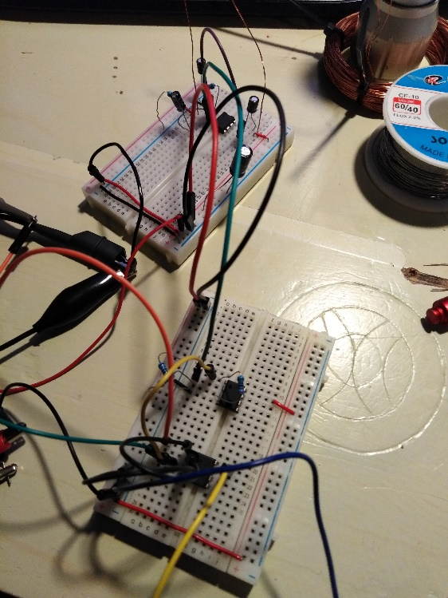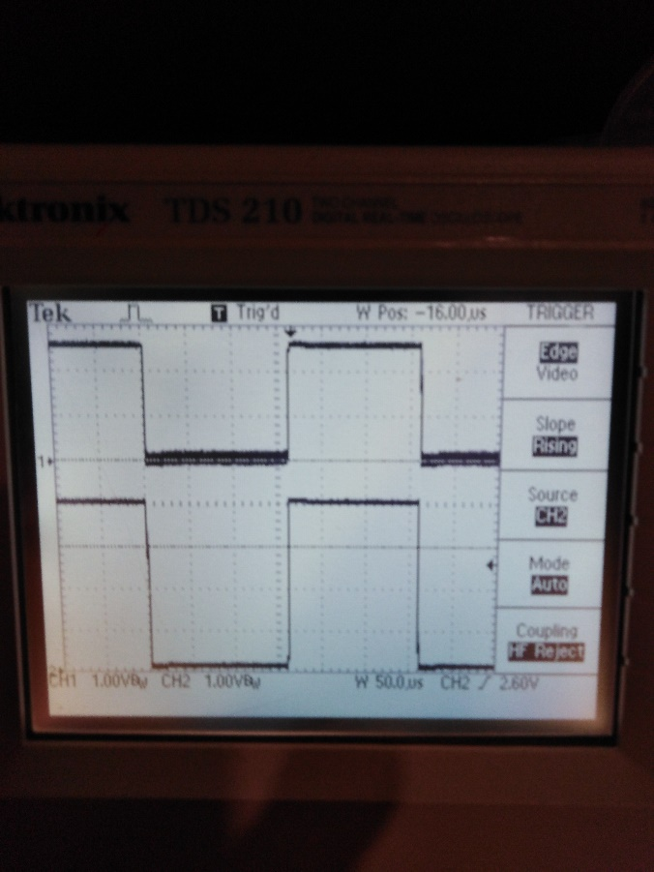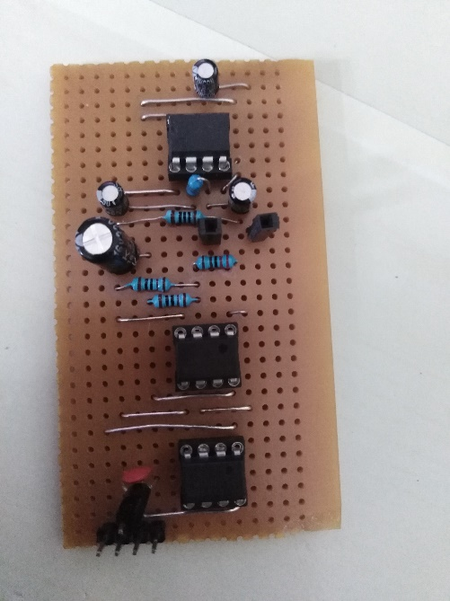

eK9 sensor is made of 555 timers two op-amps and voltage regulator. The first section is the 555 timer. It runs on 5volt. Reset (pin 4) is connected to 5 volts reset always disable. Threshold and trigger (pin 2,6) are connected to trigger when voltages are changed. Pin 7 not connected to keep energy in the coil.

U2A this op-amp operates as smiths trigger. This component triggers output when the input reaches values selected by resistors. The output of this component is a square wave from 0 volt to 5 volts

U3A this op-amp is used as a buffer to translate 5 volts to 3.3 volts. The output of this op-amp will read with esp32 to do computation with it.

Parts U2B and U3B are not used in this case. Their input is terminated to ground to minimize interference and energy consumption. 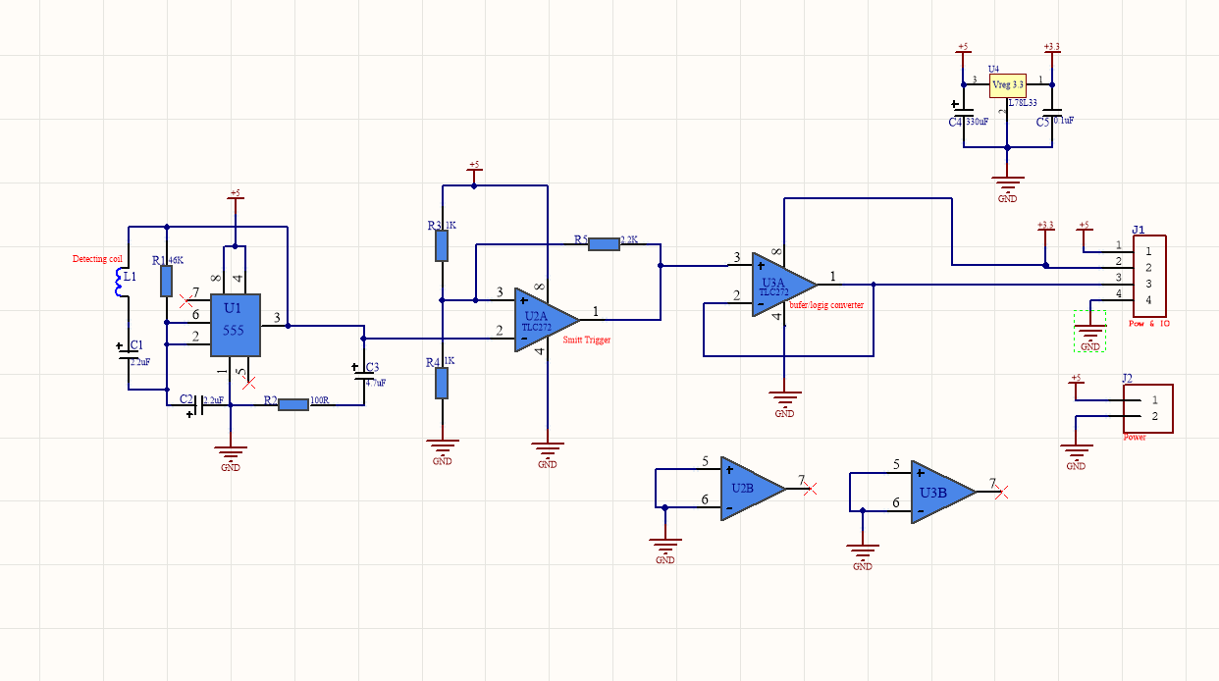

**The brain of eK9**

Esp32 will deliver enough processing power. This little beast is counting the frequency of sensor and transmitting data via Bluetooth (BLE). Development kit from Expresif the ESP32 WROM 32 has imbedded Wi-Fi and Bluetooth which can work as normal Bluetooth and as low power Bluetooth. The system is very interesting, the device work as a server and transmits small packets of data over small distances. Then another device like a smartphone set up as a client can pick up those packets and read its content. This technology will fit my needs to transmit my frequency values over a small distance to my phone for further analysis.

The smartphone will receive the data and read it. Bu value app will determine color which will be used to draw. Another type of sensors will be used is an accelerometer. The accelerometer will read the position of the phone and determine how many phones were moved and the app will know how much distance the phone traveled. Two different data will complete all the pictures. The accelerometer will determine distance how much phone is moved and the frequency value will show the intensity of the material.